http://www.w3resource.com/sql/group-by.php
https://www.w3schools.com/SQL/sql_delete.asp
https://www.w3schools.com/sql/sql_join.asp for joints

Different Types of SQL JOINs
Here are the different types of the JOINs in SQL:
- (INNER) JOIN: Returns records that have matching values in both tables
- LEFT (OUTER) JOIN: Return all records from the left table, and the matched records from the right table
- RIGHT (OUTER) JOIN: Return all records from the right table, and the matched records from the left table
- FULL (OUTER) JOIN: Return all records when there is a match in either left or right table
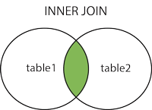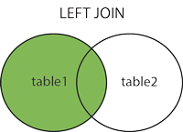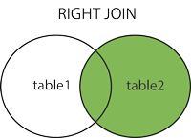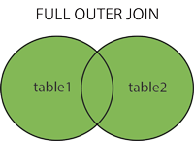

Self JOIN
A self JOIN is a regular join, but the table is joined with itself.

Self Join
Self join is used to join a database table to itself, particularly when the table has a Foreign key that references its own Primary Key. Basically we have only three types of joins : Inner join, Outer join and Cross join. We use any of these three JOINS to join a table to itself. Hence Self join is not a type of Sql join

What is Self Join in SQL?
A self join is a join in which a table is joined with itself (which is also called Unary relationships), especially when the table has a FOREIGN KEY which references its own PRIMARY KEY. To join a table itself means that each row of the table is combined with itself and with every other row of the table.
The self join can be viewed as a join of two copies of the same table. The table is not actually copied, but SQL performs the command as though it were.
The syntax of the command for joining a table to itself is almost same as that for joining two different tables. To distinguish the column names from one another, aliases for the actual the table name are used, since both the tables have the same name. Table name aliases are defined in the FROM clause of the SELECT statement. See the syntax :
SELECT a.column_name, b.column_name...
FROM table1 a, table1 b
WHERE a.common_filed = b.common_field;
For this tutorial we have used a table EMPLOYEE, that has one-to-many relationship.
Code to create the table EMPLOYEE
SQL Code:
CREATE TABLE employee(emp_id varchar(5) NOT NULL,
emp_name varchar(20) NULL,
dt_of_join date NULL,
emp_supv varchar(5) NULL,
CONSTRAINT emp_id PRIMARY KEY(emp_id) ,
CONSTRAINT emp_supv FOREIGN KEY(emp_supv)
REFERENCESemployee(emp_id));
Copy
The structure of the table
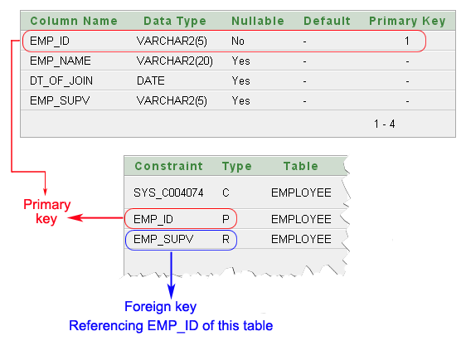

In the EMPLOYEE table displayed above, emp_id is the primary key. emp_supv is the foreign key (this is the supervisor’s employee id).
If we want a list of employees and the names of their supervisors, we’ll have to JOIN the EMPLOYEE table to itself to get this list.
Unary relationship to employee
How the employees are related to themselves:
- An employee may report to another employee (supervisor).
- An employee may supervise himself (i.e. zero) to many employees (subordinates).
We have the following data into the table EMPLOYEE
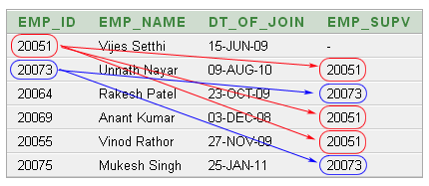
The above data shows:
- Unnath Nayar's supervisor is Vijes Setthi
- Anant Kumar and Vinod Rathor can also report to Vijes Setthi.
- Rakesh Patel and Mukesh Singh are under supervison of Unnith Nayar.

Example of SQL SELF JOIN
In the following example, we will use the table EMPLOYEE twice and in order to do this we will use the alias of the table.
To get the list of employees and their supervisor the following SQL statement has used:
SQL Code:
SELECT a.emp_id AS "Emp_ID",a.emp_name AS "Employee Name",
b.emp_id AS "Supervisor ID",b.emp_name AS "Supervisor Name"
FROM employee a, employee b
WHERE a.emp_supv = b.emp_id;
Copy
Output:
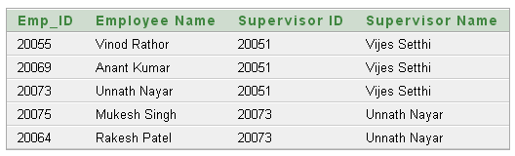
Outputs of the said SQL statement shown here is taken by using Oracle Database 10g Express

Cross Join
Cross join is a cartesian join means cartesian product of both the tables. This join does not need any condition to join two tables. This join returns records/rows that are multiplication of record number from both the tables means each row on left table will related to each row of right table. Syntax for right outer Join is as :
- Select * from table_1
- cross join table_2

Pictorial Presentation of Cross Join syntax
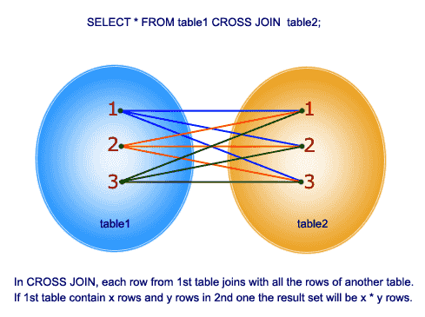

1. What Is SQL Profiler?
SQL Profiler is a tool which allows system administrator to monitor events in the SQL server. This is mainly used to capture and save data about each event of a file or a table for analysis.
2. What is sub query and its properties?
A sub-query is a query which can be nested inside a main query like Select, Update, Insert or Delete statements. This can be used when expression is allowed.
3. What is SQL server agent?
The SQL Server agent plays a vital role in day to day tasks of SQL server administrator(DBA). Server agent’s purpose is to implement the tasks easily with the scheduler engine which allows our jobs to run at scheduled date and time.
4. What are scheduled tasks in SQL Server?
Scheduled tasks or jobs are used to automate processes that can be run on a scheduled time at a regular interval. This scheduling of tasks helps to reduce human intervention during night time and feed can be done at a particular time. User can also order the tasks in which it has to be generated
5. How exceptions can be handled in SQL Server Programming?
Exceptions are handled using TRY—-CATCH constructs and it is handles by writing scripts inside the TRY block and error handling in the CATCH block.
6. What is a Trigger?
Triggers are used to execute a batch of SQL code when insert or update or delete commands are executed against a table. Triggers are automatically triggered or executed when the data is modified. It can be executed automatically on insert, delete and update operations.
7. What are the types of Triggers?
There are four types of triggers and they are:
- Insert
- Delete
- Update
- Instead of
8. What is an IDENTITY column in insert statements?
IDENTITY column is used in table columns to make that column as Auto incremental number or a surrogate key.
9. What is the difference between varchar and nvarchar types?
Varchar and nvarchar are same but the only difference is that nvarhcar can be used to store Unicode characters for multiple languages and it also takes more space when compared with varchar.
10. How to delete duplicate rows in SQL Server?
Duplicate rows can be deleted using CTE and ROW NUMER feature of SQL Server.
11. Where are SQL Server user names and passwords stored in SQL Server?
User Names and Passwords are stored in sys.server_principals and sys.sql_logins. But passwords are not stored in normal text.
12. What is the difference between GETDATE and SYSDATETIME?
Both are same but GETDATE can give time till milliseconds and SYSDATETIME can give precision till nanoseconds. SYSDATE TIME is more accurate than GETDATE.
13. What's the difference between a primary key and a unique key?
Both primary key and unique key enforces uniqueness of the column on which they are defined. But by default primary key creates a clustered index on the column, where are unique creates a nonclustered index by default. Another major difference is that, primary key doesn't allow NULLs, but unique key allows one NULL only.
14. What is difference between DELETE and TRUNCATE commands?
Delete command removes the rows from a table based on the condition that we provide with a WHERE clause. Truncate will actually remove all the rows from a table and there will be no data in the table after we run the truncate command.
  - TRUNCATE:
    - TRUNCATE is faster and uses fewer system and transaction log resources than DELETE.
    - TRUNCATE removes the data by deallocating the data pages used to store the table's data, and only the page deallocations are recorded in the transaction log.
    - TRUNCATE removes all rows from a table, but the table structure, its columns, constraints, indexes and so on, remains. The counter used by an identity for new rows is reset to the seed for the column.
    - You cannot use TRUNCATE TABLE on a table referenced by a FOREIGN KEY constraint. Because TRUNCATE TABLE is not logged, it cannot activate a trigger.
    - TRUNCATE cannot be rolled back.
    - TRUNCATE is DDL Command.
    - TRUNCATE Resets identity of the table
  - DELETE:
    - DELETE removes rows one at a time and records an entry in the transaction log for each deleted row.
    - If you want to retain the identity counter, use DELETE instead. If you want to remove table definition and its data, use the DROP TABLE statement.
    - DELETE Can be used with or without a WHERE clause
    - DELETE Activates Triggers.
    - DELETE can be rolled back.
    - DELETE is DML Command.
    - DELETE does not reset identity of the table.
Note: DELETE and TRUNCATE both can be rolled back when surrounded by TRANSACTION if the current session is not closed. If TRUNCATE is written in Query Editor surrounded by TRANSACTION and if session is closed, it can not be rolled back but DELETE can be rolled back.
15.What is the difference between a HAVING CLAUSE and a WHERE CLAUSE?
They specify a search condition for a group or an aggregate. But the difference is that HAVING can be used only with the SELECT statement. HAVING is typically used in a GROUP BY clause. When GROUP BY is not used, HAVING behaves like a WHERE clause. Having Clause is basically used only with the GROUP BY function in a query whereas WHERE Clause is applied to each row before they are part of the GROUP BY function in a query.
16. What is PRIMARY KEY?
A PRIMARY KEY constraint is a unique identifier for a row within a database table. Every table should have a primary key constraint to uniquely identify each row and only one primary key constraint can be created for each table. The primary key constraints are used to enforce entity integrity.
17. What is UNIQUE KEY constraint?
A UNIQUE constraint enforces the uniqueness of the values in a set of columns, so no duplicate values are entered. The unique key constraints are used to enforce entity integrity as the primary key constraints.
18. What is FOREIGN KEY?
A FOREIGN KEY constraint prevents any actions that would destroy links between tables with the corresponding data values. A foreign key in one table points to a primary key in another table. Foreign keys prevent actions that would leave rows with foreign key values when there are no primary keys with that value. The foreign key constraints are used to enforce referential integrity.
19. What is CHECK Constraint?
A CHECK constraint is used to limit the values that can be placed in a column. The check constraints are used to enforce domain integrity.
https://www.indiabix.com/technical/sql-server-common-questions/5

20. What are the advantages of using Stored Procedures?
- Stored procedure can reduced network traffic and latency, boosting application performance.
- Stored procedure execution plans can be reused, staying cached in SQL Server's memory, reducing server overhead.
- Stored procedures help promote code reuse.
- Stored procedures can encapsulate logic. You can change stored procedure code without affecting clients.
- Stored procedures provide better security to your data.
SQL Server stored procedures are collections of Transact-SQL (T-SQL) query statements that run inside the database...

21. What is a Cursor?
A cursor is a database object used by applications to manipulate data in a set on a row-by-row basis, instead of the typical SQL commands that operate on all the rows in the set at one time.
In order to work with a cursor, we need to perform some steps in the following order:
- Declare cursor
- Open cursor
- Fetch row from the cursor
- Process fetched row
- Close cursor
- Deallocate cursor (Read more here)

22.What is Self Join?
This is a particular case when one table joins to itself, with one or two aliases to avoid confusion. A self join can be of any type, as long as the joined tables are the same. A self join is rather unique in that it involves a relationship with only one table. The common example is when company have a hierarchal reporting structure whereby one member of staff reports to another.
23.What is Cross Join?
A cross join that does not have a WHERE clause produces the Cartesian product of the tables involved in the join. The size of a Cartesian product result set is the number of rows in the first table multiplied by the number of rows in the second table. The common example is when company wants to combine each product with a pricing table to analyze each product at each price.
24. What Are Stored Procedures?
A stored procedure is a collection of Transact-SQL statements that stored in the SQL Server. A stored procedure can be executed later with an EXEC statement. SQL Server supports stored procedures with the following features:
1. Stored procedures can be divided into 3 groups based their accessing scopes:
- Permanent Procedures - Created for permanent use.
- Global Temporary Procedures - Created for temporary use within all sessions.
- Local Temporary Procedures - Created for temporary use within the same session.
2. Stored procedures can take input parameters.
3. Stored procedures can take output parameters.
4. Stored procedures can be mapped to references to Microsoft .NET Framework common language runtime (CLR) methods.
25. How To Create a Simple Stored Procedure?
If you want to create a simple stored procedure with no input and output parameters, you can use the "CREATE PROCEDURE" command with a statement batch in a simple format as shown in below:

26. How To Create Stored Procedures with Parameters?
Very often, you need to create a stored procedure with one or more parameters. You only supply values to those parameters at the time of executing the stored procedure.
Stored procedures with parameters can be created with the following syntax:
CREATE PROCEDURE procedure_name
@parameter_1 datatype,
@parameter_2 datatype,
...
@parameter_n datatype
AS
statement_1;
statement_2;
...
statement_n;
GO
The following tutorial exercise shows you how to create a stored procedure with one parameter called @url:
USE FyiCenterData;
GO

DROP PROCEDURE Hello;
GO

CREATE PROCEDURE Hello
@url nvarchar(40)
AS
PRINT 'Welcome to ' + @url;
GO

EXEC Hello 'dba.fyicenter.com';
GO
Welcome to dba.fyicenter.com
27. How will you handle Errors in Sql Stored Procedure?
INSERT NonFatal VALUES (@Column2)
IF @@ERROR <>0
BEGIN
PRINT 'Error Occured'
END

CREATE PROCEDURE procedure_name AS
statement_1;
statement_2;
...
statement_n;
GO
The following tutorial exercise shows you how to create a simple stored procedure:

USE FyiCenterData;
GO

CREATE PROCEDURE Hello AS
SELECT 'Welcome to:';
SELECT ' FYIcenter.com';
GO
Command(s) completed successfully.

EXEC Hello;
GO

-----------
Welcome to;
(1 row(s) affected)

----------------
FYIcenter.com
(1 row(s) affected)
28.How To Execute a Stored Procedure?
If you want execute a stored procedure created previously, you can use the EXECUTE statement in the following formats:
EXEC procedure_name;
EXECUTE procedure_name;
The key word EXEC is actually optional. So you can execute a stored procedure by just entering the procedure name as the statement. See examples in the following tutorial exercise:
USE FyiCenterData;
GO

-- create a quick procedure
CREATE PROCEDURE date AS
PRINT CONVERT(VARCHAR(20),GETDATE(),107);
GO

-- execute with EXEC
EXEC date;
GO
May 19, 2007

-- execute with EXEC
date;
GO
May 19, 2007

-- using a reserved keyword as procedure name
CREATE PROCEDURE datetime AS PRINT GETDATE();
GO

datetime;
GO
May 19, 2007 11:35PM

29. Difference between view and stored procedure?
Views can have only select statements (create, update, truncate,
delete statements are not allowed) Views cannot have "select into",
"Group by" "Having", "Order by"
30. What is a Function & what are the different user defined functions?
Function is a saved Transact-SQL routine that returns a value.
User-defined functions cannot be used to perform a set of actions that
modify the global database state. User-defined functions, like system
functions, can be invoked from a query. They also can be executed
through an EXECUTE statement like stored procedures.
31. What are the difference between a function and a stored procedure?
0. Functions can be used in a select statement where as procedures cannot
1. Procedure takes both input and output parameters but Functions
takes only input parameters
2. Functions cannot return values of type text, ntext, image &
timestamps where as procedures can
3. Functions can be used as user defined datatypes in create table but
procedures cannot
***Eg:-create table (name varchar(10),salary getsal(name))
Here getsal is a user defined function which returns a salary type,
when table is created no storage is allotted for salary type, and
getsal function is also not executed, But when we are fetching some
values from this table, getsal function get's executed and the return

32. What is de-normalization in SQL database administration? Give examples
De-normalization is used to optimize the readability and performance of the database by adding redundant data. It covers the inefficiencies in the relational database software.
De-normalization logical data design tend to improve the query responses by creating rules in the database which are called as constraints.
Examples include the following :
- Materialized views for implementation purpose such as :
- Storing the count of “many” objects in one-to-many relationship.
- Linking attribute of one relation with other relations.
- To improve the performance and scalability of web applications.
33. Normalization
it is the process of efficiently organizing data in a database. There are two goals of the normalization process: eliminating redundant data (for example, storing the same data in more than one table) and ensuring data dependencies make sense (only storing related data in a table).

There are diff. - diff. types of Normalizations form available in the Database. Lets see one by one.
1. First Normal Form (1NF)
First normal form (1NF) sets the very basic rules for an organized database:
- Eliminate duplicative columns from the same table.
- Create separate tables for each group of related data and identify each row with a unique column or set of columns (the primary key).
  - Remove repetative groups
  - Create Primary Key

Name | State | Country | Phone1 | Phone2 | Phone3
John | 101 | 1 | 488-511-3258 | 781-896-9897 | 425-983-9812
Bob | 102 | 1 | 861-856-6987
Rob | 201 | 2 | 587-963-8425 | 425-698-9684
PK |  |  | [ Phone Nos ]
? |  |  |  | ?
ID | Name | State | Country | Phone
1 | John | 101 | 1 | 488-511-3258
2 | John | 101 | 1 | 781-896-9897
3 | John | 101 | 1 | 425-983-9812
4 | Bob | 102 | 1 | 861-856-6987
5 | Rob | 201 | 2 | 587-963-8425
6 | Rob | 201 | 2 | 425-698-9684
2. Second Normal Form (2NF)Second normal form (2NF) further addresses the concept of removing duplicative data:
• Meet all the requirements of the first normal form.
• Remove subsets of data that apply to multiple rows of a table and place them in separate tables.
· Create relationships between these new tables and their predecessors through the use of foreign keys.
Remove columns which create duplicate data in a table and related a new table with Primary Key – Foreign Key relationship

ID | Name | State | Country | Phone
1 | John | 101 | 1 | 488-511-3258
2 | John | 101 | 1 | 781-896-9897
3 | John | 101 | 1 | 425-983-9812
4 | Bob | 102 | 1 | 861-856-6987
5 | Rob | 201 | 2 | 587-963-8425
6 | Rob | 201 | 2 | 425-698-9684
ID | Name | State | Country |  | PhoneID | ID | Phone
1 | John | 101 |  |  | 1 | 1 | 488-511-3258
2 | Bob | 102 |  |  | 2 | 1 | 781-896-9897
3 | Rob | 201 |  |  | 3 | 1 | 425-983-9812
 |  |  |  |  | 4 | 2 | 587-963-8425
 |  |  |  |  | 5 | 3 | 587-963-8425
 |  |  |  |  | 6 | 3 | 425-698-9684

3. Third Normal Form (3NF)
Third normal form (3NF) goes one large step further:
• Meet all the requirements of the second normal form.
• Remove columns that are not dependent upon the primary key.
Country can be derived from State also… so removing country
ID | Name | State | Country
1 | John | 101 | 1
2 | Bob | 102 | 1
3 | Rob | 201 | 2

4. Fourth Normal Form (4NF)

Finally, fourth normal form (4NF) has one additional requirement:
• Meet all the requirements of the third normal form.
• A relation is in 4NF if it has no multi-valued dependencies.

If PK is composed of multiple columns then all non-key attributes should be derived from FULL PK only. If some non-key attribute can be derived from partial PK then remove it

The 4NF also known as BCNF NF

TeacherID | StudentID | SubjectID | StudentName
101 | 1001 | 1 | John
101 | 1002 | 2 | Rob
201 | 1002 | 3 | Bob
201 | 1001 | 2 | Rob
TeacherID | StudentID | SubjectID | StudentName
101 | 1001 | 1 | X
101 | 1002 | 2 | X
201 | 1001 | 3 | X
201 | 1002 | 2 | X

34.The following constraints are commonly used in SQL:
- NOT NULL - Ensures that a column cannot have a NULL value.
- UNIQUE - Ensures that all values in a column are different.
- PRIMARY KEY - A combination of a NOT NULL and UNIQUE. ...
- FOREIGN KEY - Uniquely identifies a row/record in another table.
PrimaryKey:
Primary Key enforces uniqueness of the column on which they are defined. Primary Key creates a clustered index on the column. Primary Key does not allow Nulls.
- Create table with Primary Key:
CREATE TABLE Authors (
AuthorID INT NOT NULL PRIMARY KEY,
Name VARCHAR(100) NOT NULL
)
GO
Alter table with Primary Key:
ALTER TABLE Authors
ADD CONSTRAINT pk_authors PRIMARY KEY (AuthorID)
GO
Unique Key:
Unique Key enforces uniqueness of the column on which they are defined. Unique Key creates a non-clustered index on the column. Unique Key allows only one NULL Value.

35. Difference Between Primary Key and Unique Key In Sql Server
Both PRIMARY KEY and UNIQUE KEY enforces the Uniqueness of the values (i.e. avoids duplicate values) on the column[s] on which it is defined. Also these key’s can Uniquely identify each row in database table.
[ALSO READ] Difference Between Sql Server VARCHAR and NVARCHAR Data Type
Below table lists out the major difference between PRIMARY KEY and UNIQUE KEY:
 | PRIMARY KEY | UNIQUE KEY
NULL | It doesn’t allow Null values.  Because of this we refer  PRIMARY KEY = UNIQUE KEY + Not Null CONSTRAINT | Allows Null value. But only one Null value.
INDEX | By default it adds a clustered index | By default it adds a UNIQUE non-clustered index
LIMIT | A table can have only one PRIMARY KEY Column[s] | A table can have more than one UNIQUE Key Column[s]
CREATE SYNTAX | Below is the sample example for defining a single column as a PRIMARY KEY column while creating a table:CREATE TABLE dbo.Customer  (  Id INT NOT NULL PRIMARY KEY,  FirstName VARCHAR(100),  LastName VARCHAR(100),  City VARCHAR(50)  )  Below is the Sample example for defining multiple columns as PRIMARY KEY. It also shows how we can give name for the PRIMARY KEY:  CREATE TABLE dbo.Customer  (  Id INT NOT NULL,  FirstName VARCHAR(100) NOT NULL,  LastName VARCHAR(100),  City VARCHAR(50),  CONSTRAINT PK_CUSTOMER PRIMARY KEY (Id,FirstName)  ) | Below is the sample example for defining a single column as a UNIQUE KEY column while creating a table:CREATE TABLE dbo.Customer  (  Id INT NOT NULL UNIQUE,  FirstName VARCHAR(100),  LastName VARCHAR(100),  City VARCHAR(50)  )  Below is the Sample example for defining multiple columns as UNIQUE KEY. It also shows how we can give name for the UNIQUE KEY:  CREATE TABLE dbo.Customer  (  Id INT NOT NULL,  FirstName VARCHAR(100) NOT NULL,  LastName VARCHAR(100),  City VARCHAR(50),  CONSTRAINT UK_CUSTOMER UNIQUE (Id,FirstName)  )
ALTER SYNTAX | Below is the Syntax for adding PRIMARY KEY CONSTRAINT on a column when the table is already created and doesn’t have any primary key:ALTER TABLE dbo.Customer  ADD CONSTRAINT PK_CUSTOMER PRIMARY KEY (Id) | Below is the Syntax for adding UNIQUE KEY CONSTRAINT on a column when the table is already created:ALTER TABLE dbo.Customer  ADD CONSTRAINT UK_CUSTOMER UNIQUE (Id)
DROP SYNTAX | Below is the Syntax for dropping a PRIMARY KEY:ALTER TABLE dbo.Customer  DROP CONSTRAINT PK_CUSTOMER | Below is the Syntax for dropping a UNIQUE KEY:ALTER TABLE dbo.Customer  DROP CONSTRAINT UK_CUSTOMER

ALSO READ

UNION
The UNION command is used to select related information from two tables, much like the JOIN command. However, when using the UNION command all selected columns need to be of the same data type. With UNION, only distinct values are selected.
36 .UNION ALL
The UNION ALL command is equal to the UNION command, except that UNION ALL selects all values.
The difference between Union and Union all is that Union all will not eliminate duplicate rows, instead it just pulls all rows from all tables fitting your query specifics and combines them into a table.
A UNION statement effectively does a SELECT DISTINCT on the results set. If you know that all the records returned are unique from your union, use UNION ALL instead, it gives faster results.
UNION removes duplicate records (where all columns in the results are the same), UNION ALL does not.
There is a performance hit when using UNION vs UNION ALL, since the database server must do additional work to remove the duplicate rows, but usually you do not want the duplicates (especially when developing reports).

UNION Example:
SELECT 'foo' AS bar UNION SELECT 'foo' AS bar
Result:
+-----+
| bar |
+-----+
| foo |
+-----+
1 row in set (0.00 sec)

UNION ALL example:
SELECT 'foo' AS bar UNION ALL SELECT 'foo' AS bar
Result:
+-----+
| bar |
+-----+
| foo |
| foo |
+-----+
2 rows in set (0.00 sec)
Summary
UNION | UNION ALL
UNION removes duplicate rows. | “UNION ALL” does not remove the duplicate row. It returns all from all queries.
UNION uses a distinct sort | “UNION ALL” does not use a distinct sort, so the performance of “UNION ALL” is slightly higher than “UNION”.
UNION cannot work with a column that has a TEXT data type. | UNION ALL can work with all data type columns.
Each SELECT statement within the UNION / UNION ALL must have the same number of columns and the columns must have similar or compatible data types. They must be in the same order.

Introduction
In SQL Server we have the concept about sub queries. Sub queries means query within the query. Lets take a example of sub query. Suppose we want to find out the nth largest salary among the given salaries so for this purpose we have to use sub query.
Lets have a look on the following example.
I have created Employee table with following values.
1st method
To select 2nd highest salary or record we can use following query.
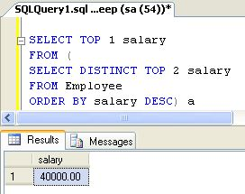
OR
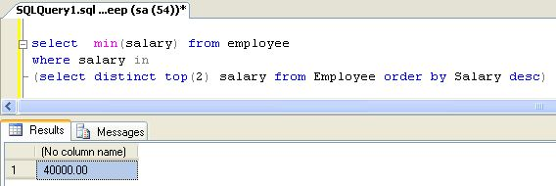
2nd method
To select 3rd highest salary or record we can use following query.
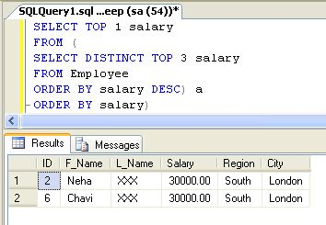
3rd method
To select nth largest salary or record from above table, we can use following query.
select top 1 salary from (select distinct top n salary from Employee order by salary desc) a order by salary

Related Articles

How to use count and group by at the same select statement:
select town, count(*) from user
group by town
I want to have a column with all the towns and another with the number of users in all rows.
An example of the result for having 3 towns and 58 users in total is :
Town Count
Copenhagen 58
NewYork 58
Athens 58

The SQL GROUP BY Statement:
SELECT column_name(s)
FROM table_name
WHERE condition
GROUP BY column_name(s)
ORDER BY column_name(s);

SELECT COUNT(CustomerID), Country
FROM Customers
GROUP BY Country
ORDER BY COUNT(CustomerID) DESC;
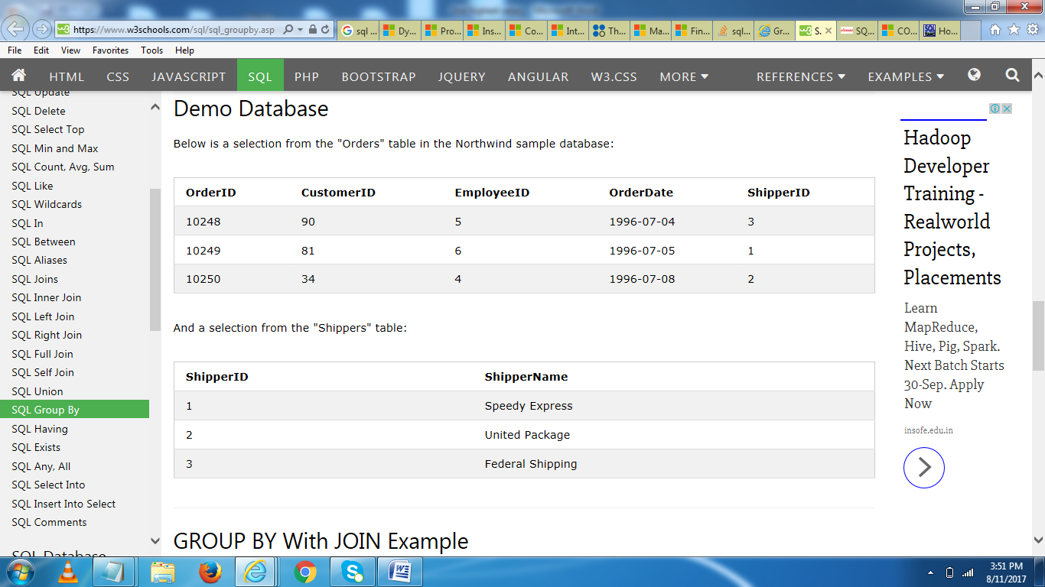

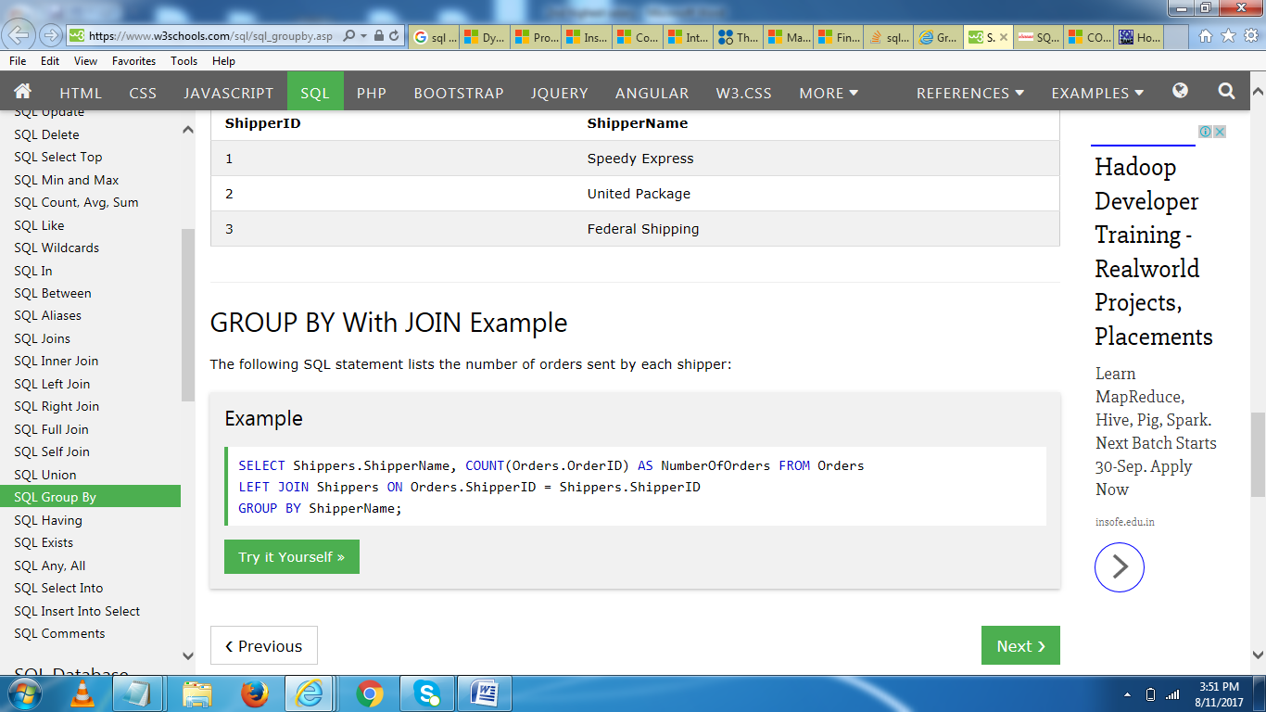

Count with group by
The use of COUNT() function in conjunction with GROUP BY is useful for characterizing our data under various groupings. A combination of same values (on a column) will be treated as an individual group.
Example :
To get data of 'working_area' and number of agents for this 'working_area' from the 'agents' table with the following condition -
1. 'working_area' should come uniquely,
the following SQL statement can be used :
view plaincopy to clipboardprint?
- SELECT working_area, COUNT(*)
- FROM agents
- GROUP BY working_area;

Sample table : agents
Output
WORKING_AREA COUNT(*)
----------------------------------- ----------
San Jose 1
Torento 1
London 2
Hampshair 1
New York 1
Brisban 1
Bangalore 3
Chennai 1
Mumbai

G. Using COUNT with HAVING
The following example uses COUNT with the HAVING clause to return the departments in a company that have more than 15 employees.+
SQLCopy
USE ssawPDW;

SELECT DepartmentName,
COUNT(EmployeeKey)AS EmployeesInDept
FROM dbo.DimEmployee
GROUP BY DepartmentName
HAVING COUNT(EmployeeKey) > 15;
Here is the result set. +
DepartmentName EmployeesInDept+
-------------- ---------------+
Sales 18+
Production 179
SELECT * FROM CUSTOMERS
ORDER BY (customer_id) DESC;
CREATE TABLE CUSTOMERS(
customer_id INT,
first_name VARCHAR (20),
last_name VARCHAR (20),
email VARCHAR(30),
C_address VARCHAR (40),
city VARCHAR (20),
C_state VARCHAR (20),
ZIPCODE INT,
PRIMARY KEY (customer_id)
);

insert into CUSTOMERS(customer_id,first_name,last_name,email,C_address,city,C_state,ZIPCODE) values(1,'George','washington','gwashington','3200 Mt VemonHWY','mount vemon','VA',22121)
insert into CUSTOMERS(customer_id,first_name,last_name,email,C_address,city,C_state,ZIPCODE) values(2,'john','adams','jadams','1250 hancock st','charlottesville','va',02169)
insert into CUSTOMERS(customer_id,first_name,last_name,email,C_address,city,C_state,ZIPCODE) values(3,'thomas','jefferson','tjefferson','931 thomas','cha','va',22902)
insert into CUSTOMERS(customer_id,first_name,last_name,email,C_address,city,C_state,ZIPCODE) values(4,'hemanth','iesfa','ksdf','54 jksd','jkd','hf',3422)
select * from CUSTOMERS;

SQL Joints with Examples?
CREATE TABLE section(
order_id INT,
order_date DATETIME,
customer_id INT,
primary KEY (order_id)
);
insert into section(order_id,order_date,customer_id) values(11,10-06-1995,1);
insert into section(order_id,order_date,customer_id) values(22,10-06-1996,2);
insert into section(order_id,order_date,customer_id) values(44,10-06-1999,5);
update section set order_id=66
select * from section ,CUSTOMERS where section.customer_id=CUSTOMERS.customer_id

select *from CUSTOMERS
full outer JOIN dbo.section
ON CUSTOMERS.customer_id = section.customer_id

select *from CUSTOMERS
left JOIN section
ON CUSTOMERS.customer_id = section.customer_id

select * from CUSTOMERS
right join section
on CUSTOMERS.customer_id = section.customer_id

select * from CUSTOMERS
INNER join section

on CUSTOMERS.customer_id = section.customer_id
select *from CUSTOMERS right join section
on CUSTOMERS.customer_id=section.customer_id;

create table a(
pid numeric(25),
normal varchar(35),
);
insert into a(pid,normal) values(123,'hhh');
insert into a(pid,normal) values(345,'fff');
insert into a(pid,normal) values(433,'ggg');
select*from a;

UPDATE a
SET pid=222
WHERE normal='hhh';

create table abc(
name varchar(15),
salary int
);

insert into abc(name, salary) values('ram',100000);
insert into abc(name, salary) values('kiran',1000000);
insert into abc(name, salary) values('suresh',40000);
insert into abc(name, salary) values('ravi',500000);

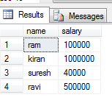

\\ 1st highest salary syntax //
Select Max(Salary) as Highest_Salary From (Select Top 1 * From abc Order by Salary Desc) abc
Or
Select max(salary) from abc
or
SELECT name, salary FROM abc e1 WHERE 1-1 = (SELECT COUNT(DISTINCT salary) FROM abc e2 WHERE e2.salary > e1.salary)

\\ 2nd highest salary syntax //
select name,salary
from abc where salary=(select max(salary) from abc where salary <(SELECT max(salary) from abc)) or
SELECT name, salary FROM abc e1 WHERE 2-1 = (SELECT COUNT(DISTINCT salary) FROM abc e2 WHERE e2.salary > e1.salary)
\\ 3rd highest salary syntax //
SELECT name, salary FROM abc e1 WHERE 3-1 = (SELECT COUNT(DISTINCT salary) FROM abc e2 WHERE e2.salary > e1.salary)
or
SELECT TOP 1 salary FROM
(SELECT TOP 3 salary
FROM abc
ORDER BY salary DESC) AS Comp
ORDER BY salary ASC
\\max and min salary//
select name,salary from abc where salary in((select max(salary) from abc) ,
(select min(salary) from abc))
Group by and order by examples?
CREATE TABLE employees(
employee_id numeric (34),
first_name varchar(25),
last_name varchar(35),
email varchar(30),
phone_number numeric(15),
hire_date dATE,
job_id VARCHAR(15),
salary NUMERIC(20),
commission_pct NUMERIC,
manager_id NUMERIC,
department_id NUMERIC
);
INSERT INTO employees(employee_id,first_name,last_name,email,phone_number,hire_date,job_id,salary,commission_pct,manager_id,department_id)VALUES(100,'Steven','King','SKING',7382659801,'6-17-1987','AD_PRES', 24000,02,45,90);
INSERT INTO employees(employee_id,first_name,last_name,email,phone_number,hire_date,job_id,salary,commission_pct,manager_id,department_id)VALUES(101, 'Neena','Kochhar','NKOCHHAR',5151234568,'6/18/1987','AD_VP',17000,03,100,90)
INSERT INTO employees(employee_id,first_name,last_name,email,phone_number,hire_date,job_id,salary,commission_pct,manager_id,department_id)VALUES(102,'Lex','De Haan','LDEHAAN',5151234569,'6/19/1987','AD_VP',17000,04,100,90)
INSERT INTO employees(employee_id,first_name,last_name,email,phone_number,hire_date,job_id,salary,commission_pct,manager_id,department_id)VALUES(103,'Axander','Hunold','AHUNOLD',5904234567,'6/20/1987','IT_PROG',9000,88,102,60)
INSERT INTO employees(employee_id,first_name,last_name,email,phone_number,hire_date,job_id,salary,commission_pct,manager_id,department_id)VALUES(104,'Bruce','Ernst','BERNST',5904234568,'6/21/1987','IT_PROG',6000,45,103,60)
INSERT INTO employees(employee_id,first_name,last_name,email,phone_number,hire_date,job_id,salary,commission_pct,manager_id,department_id)VALUES(105,'David','Austin','DAUSTIN',590424569,'6/22/1987','IT_PROG', 4800,55,103,60)
INSERT INTO employees(employee_id,first_name,last_name,email,phone_number,hire_date,job_id,salary,commission_pct,manager_id,department_id)VALUES(108,'Nancy','Greenberg','NGREENBE',5151244569,'6/25/1987','FI_MGR',12000,35,101,100)
INSERT INTO employees(employee_id,first_name,last_name,email,phone_number,hire_date,job_id,salary,commission_pct,manager_id,department_id)VALUES(109,'Daniel','Faviet','DFAVIET',5151244169,'6/26/1987','FI_ACCOUNT',9000,54,108,100)
INSERT INTO employees(employee_id,first_name,last_name,email,phone_number,hire_date,job_id,salary,commission_pct,manager_id,department_id)VALUES(109,'Daniel','Faviet','DFAVIET',5151244169,'6/26/1987','FI_ACCOUNT',9000,54,108,50)

SELECT department_id "Department Code",
COUNT(*) "No of Employees"
FROM employees
GROUP BY department_id;

SELECT department_id "Department Code",
MAX(salary) " Salary"
FROM employees
GROUP BY department_id;

SELECT department_id, count(*) "No. of Employee"
FROM employees
GROUP BY department_id
HAVING count(*)>2;

select department_id, max(salary),min(salary)
from employees
group by department_id

select department_id, avg(salary),sum(salary)
from employees
group by department_id

select department_id,salary
from employees
where salary between 4000 and 25000

select department_id,salary
from employees
where salary >=8000
select department_id,salary

Benefit | Explanation
Modular programming | You can write a stored procedure once, then call it again and again, from different parts of an application (and even from multiple applications).
Performance | Stored procedures provide faster code execution and reduce network traffic.  Faster execution: Stored procedures are parsed and optimized as soon as they are created and the stored procedure is stored in memory. This means that it will execute a lot faster than sending many lines of SQL code from your application to the SQL Server. Doing that requires SQL Server to compile and optimze your SQL code every time it runs.  Reduced network traffic: If you send many lines of SQL code over the network to your SQL Server, this will impact on network performance. This is especially true if you have hundreds of lines of SQL code and/or you have lots of activity on your application. Running the code on the SQL Server (as a stored procedure) eliminates the need to send this code over the network. The only network traffic will be the parameters supplied and the results of any query.
Security | Users can execute a stored procedure without needing to execute any of the statements directly. Therefore, a stored procedure can provide advanced database functionality for users who wouldn't normally have access to these tasks, but this functionality is made available in a tightly controlled way.
from employees
order by salary desc
where department_id=90

What is stored procedure ?
A stored procedure is a named collection of SQL statements and procedural logic i.e, compiled, verified and stored in the server database. A stored procedure is typically treated like other database objects and controlled through server security mechanism.

Benefits of Stored Procedures
Here are some of the main benefits in using stored procedures:

Create a Stored Procedure

To create a stored procedure, you need to use the CREATE PROCEDURE statement, followed by the code that makes up the stored procedure. If your stored procedure is going to accept parameters, they need to be included after the name.

example
CREATE PROCEDURE LatestTasks @Count int AS
SET ROWCOUNT @Count
SELECT TaskName AS LatestTasks, DateCreated
FROM Tasks
ORDER BY DateCreated DESC
What is composite key?
A composite key is a combination of two or more columns in a table that can be used to uniquely identify each row in the table when the columns are combined uniqueness is guaranteed, but when it taken individually it does not guarantee uniqueness. ... It may be a candidate key or primary key.

What is the difference between composite key and candidate key?
A candidate key is a unique key that can be used as a primary key. Composite key is a key of two or more attributes that uniquely identifies the row. A key is a set of columns that can be used to uniquely identify each row within a table.

Candidate Key – A Candidate Key can be any column or a combination of columns that can qualify as unique key in database. There can be multiple Candidate Keys in one table. Each Candidate Key can qualify as Primary Key. Primary Key – A Primary Key is a column or a combination of columns that uniquely identify a record.

